**Project Design Phase-II**

**Data Flow Diagram & User Stories**

|  |  |
| --- | --- |
| Date | 27 June 2025 |
| Team ID | LTVIP2025TMID43995 |
| Project Name | Transfer Learning-based Classification of Poultry Diseases for Enhanced Health Management |
| Maximum Marks | 4 Marks |

**Data Flow Diagram**

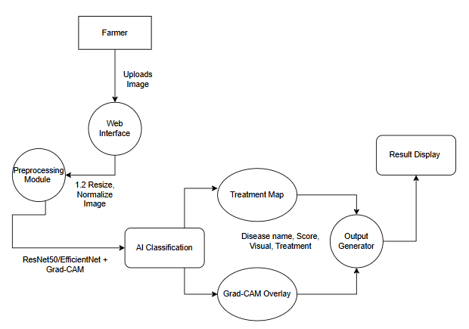

**User Stories**

|  |  |  |  |  |  |  |
| --- | --- | --- | --- | --- | --- | --- |
| User Type | Functional Requirement (Epic) | User Story Number | User Story / Task | Acceptance Criteria | Priority | Release |
| Farmer (Web User) | Registration/Login | USN-1 | As a user, I want to register using email & password | I can create and access an account | High | Sprint-1 |
| Farmer (Web User) | Registration/Login | USN-2 | As a user, I want to receive a confirmation email upon registration | I get confirmation email and can verify my account | High | Sprint-1 |
| Farmer (Web User) | Upload Image + Symptoms | USN-3 | As a user, I want to upload an image and enter symptoms | I can upload image and submit form | High | Sprint-2 |
| Farmer (Web User) | View Results | USN-4 | As a user, I want to get a disease prediction and treatment suggestion | I see disease name, treatment, and explanation | High | Sprint-2 |
| Vet / Student | View History / Feedback | USN-5 | As a user, I want to see past predictions and system output for review | I see a prediction history and can learn from it | Medium | Sprint-3 |
| Admin | Admin Panel | USN-6 | As an admin, I want to view and manage all submitted predictions | I can access dashboard of all user activities | Medium | Sprint-3 |
| Farmer (Web User) | Language Preference | USN-7 | As a user, I want to switch to my preferred language (e.g., Telugu/Hindi/English) | I can view UI and outputs in my chosen language | Medium | Sprint-3 |